**Communication Networks**

LAN measurement

Student report v2.3/1.1

Name: Klevis Imeri  
NEPTUN: T4XGKO  
E-mail: klevisimeri11@gmail.com  
Date: 23/04/2024

Please fill in the above part of this report file with your data!  
Change the YOURNEPTUN part of this file’s name to your NEPTUN CODE!  
Please fill in the **GREEN FRAME** parts with YOUR ANSWERS OR SCREENSHOTS!  
Please do NOT take full screen screenshots! Only insert the important parts of it to this document!  
You can use ALT+Print Screen to capture only the current window or better use a tool like **Snipping Tool** which is part of Windows.

If you get stuck, first check the LAN_User Guide. If it does not help, you can send questions on Communication Networks LAN measurement channel in Teams.

Submit this file to Teams channel:

Communication Networks LAN measurement Assignments

The measurement was developed by: Majdán András

Németh Krisztián

Orosz Péter

Skopkó Tamás

2019 - 2024

Content

Before starting 3

The Big Picture 4

Task 1. : Starting GNS3 5

VirtualBox 5

Ubuntu 5

GNS3 6

Task 2.: Creating the network 8

VPCS 9

MikroTik 9

Extra: NAT after NAT 10

MikroTik/WinBox 11

Configuring the DHCP server 12

Task 3.: Investigating DHCP and ARP 14

Requesting an IP address 14

Adding another subnet 16

Investigating ARP 16

Creating a NAT on the router to complete the joy 17

Appendix: GNS3 Installation Dilemmas 18

# Before starting

We hope that this measurement can be completed in 4*45 minutes. Maybe it will take you more, maybe less. This is not the most important thing, but how much you profit from it. You will learn if you ask yourself from time to time, "Why am I doing this now?" It's too easy to copy a command line into the terminal without thinking through what exactly it means.

We compiled this measurement with a lot of work and great care. Welcome with love! Take your time, pay attention, even bravely go on an adventure, play with it, learn from it! Feel free to ask if you get stuck! If you find an error, feel free to report it!

*Enjoy the ride!*

# The Big PictureMikroTik RBD52G-5HACD2HND-TC router vásárlás, olcsó MikroTik ...

*Introduction* This measurement was carried out in the university lab before distance learning was ordered in the spring of 2020 due to the coronavirus, using palm-sized WLAN-capable routers called MikroTik hAP ac2 (the small 2 here is not a footnote, this is the name of the device).

When we had to convert the measurement to be done remotely, we were a bit saddened that without real hardware, the measurement might not be so "exciting" and "lifelike". However, as so often, the forced change brought good, and we think that we managed to put together a much better measurement, which is also perhaps easier to understand. We therefore decided to keep the changed measurement in attendance education as well. 

*Hardware virtualisation* IBM used it already in the 1960s, and around 2000 this concept reached the PC industry. You've probably met it many times, but we'll describe what it is in one sentence. It is about using virtualization software to emulate computer hardware on an operating system running on a real computer ("host" operating system), on which another ("guest") operating system can be installed. This concept will come up many times now.

*GNS3.* During the measurement, we will use the network emulator program called GNS3. Based on its name, it is a simulator (Graphical Network Simulator-3), but we would prefer to call it an emulator, because in many cases it does not "pretend" but "just it is". In this software, endpoints (PCs), Ethernet switches, routers and other network elements can be placed and then connected to each other. The best part is that it doesn't just simulate their operation, but starts their (real) software in a virtual machine. And all of this in such a way that it all runs without any problems on an average PC.

We will therefore work with real router software, with the software of the MikroTik device above. There were many other routers to choose from, but this one was given and just as good for us as any other.

As easy GNS3 is to manage, it is just as fiddly to install. We will write more about this in the Appendix at the end of this document, but just for your interest. In short, it's complicated and takes a long time. The solution is of course the usual one: we, the instructors, create a virtual machine (Virtual Machine, VM) in which we pre-install and configure everything so that you just have to use it. This was not self-evident either (see Appendix), but it is there. Only for you, only now.

*About the report* Generally, the measurement report contains only the short questions and the answers determined by the measurement. Here, together with the task, we present most of the necessary information, so this document is roughly twenty pages long, even without the answers. Don't worry, believe us, it will be good this way!

# Task 1. : Starting GNS3

## VirtualBox

Download the pre-installed VM in file gns3-kh2lan-4.ova from the following link:

Teams Group of the course Communication Networks / IPTV measurement channel / Files / [gns3-kh2lan-4.ova](https://bmeedu-my.sharepoint.com/:u:/g/personal/adamis_gusztav_vik_bme_hu/ETP9iI-hWMxIsOQA86GO-acB_h3nmop2ggIK5qMaL6ljsw?e=ztd5kT)

Please note, the file size is 3.5 gigabytes. This can take hours with a low speed internet connection. It is worth downloading the file in advance, even the day before the measurement. However, this makes for a great warm-up exercise:

**T1.1** How fast is your internet connection to download? If you know the data you subscribed to, use it! If not, measure it. For this, you can use, for example a <https://www.speedtest.net/> Give the answer in Mbps (megabits/second, not megabytes/second)!

~510Mbps

**T1.2** The size of the file gns3-kh2lan-4.ova to download is 3.661.723.648 Byte. Calculate how many minutes the file is expected to take to download! (We are waiting for the answer in minutes.) Remember that both the speed values given by the service providers and those displayed on the above link are measured in Mbps (megabits per second), which is 1,000,000 bits/s (and not 1024*1024 bps). Also pay attention to the bit-byte conversion!

File size in bits = 3,661,723,648 bytes * 8 bits/byte = 29,293,789,184 bits

Time to download = File size in bits / Internet speed in bits per second

= 29,293,789,184 bits / 510,000,000 bits per second

≈ 57.44 seconds

≈ 0.957 minutes

The next step is to import the file into the virtualization software. We made it with VirtualBox, we recommend that you use it, too! VirtualBox can be installed from <https://www.virtualbox.org/>. Add the Extension Pack as well!

Importing the downloaded ova file takes a few minutes at best, but it can take up to half an hour, and it requires about 10-11 gigabytes of free space on the disk. But don't worry, only the beginning is difficult!

Things to do in VirtualBox: File/Import Appliance, select the downloaded file from the local file system, Next, Import.

Note: if a Windows folder is added to the Shared folders in Configuration (not "read-only", but "automatic attachment", the "mounting point"/"attachment point" can be left empty) then the guest operating system will see it this under /media/sf_virtualbox_shared/ (you will need sudo), so you can exchange files between the two operating systems. However, this is not critical, one can easily exist without it.

Now the VM can finally be started.

## Ubuntu

Starting the virtual machine, you will find yourself in a classic Ubuntu Linux. Though it is an older Ubuntu 16.04, but it is perfectly suitable for the measurement, and updating it would have been an unnecessarily large amount of work. A related tip: all "Do you want to update?", "Download a new version?" type of question, press No. It will be fine for these few hours.

So Ubuntu. It can be displayed in full screen or so that the host operating system is not even visible (in VirtualBox: View/Full screen mode). In the latter case, the pop-up menu of VirtualBox will be in the bottom center of the screen, if you come back to the host operating system. [1]

For those who are used to Windows, it may be interesting and certainly strange that the menu bar of the applications is not at the top of the given window, but at the very top of the entire screen, but it only appears there when the mouse cursor is moved there. Try it, it's there, you just can't see it

Note: If Ubuntu throws up a window in which it complains under the title "Update information" that it failed to download extra data files, don't panic. The system would update itself in the background, but it didn't really succeed here. However, we can easily complete this measurement without updating this character set package, so feel free to click Close.

As we wrote above, if the system offers you new update options, feel free to reject them and focus on your task.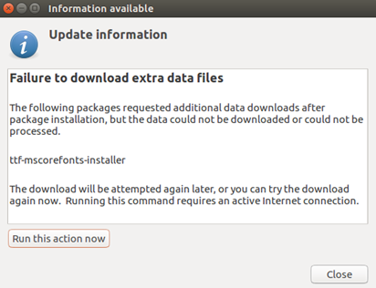

## GNS3

GNS3 can be started with the gecko (lizard? dragon?) icon displayed in the left menu bar. (Or Search your computer, GNS3)

Let's start a new project and give it a catchy name!

Then a window like this will appear in good case: (yes, I know, "proba" is not very striking)

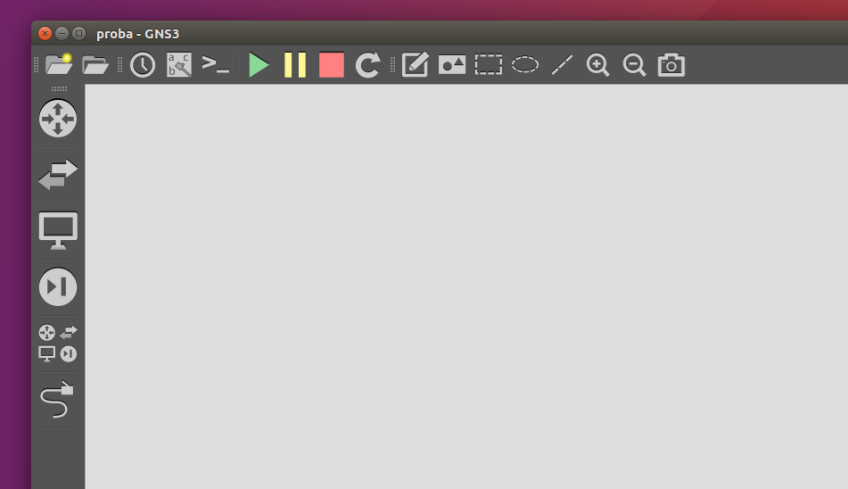

*Fig 1. GNS3 Start page*

Of course, the menu is hidden at the top, but you don't really need it anyway.

The most important buttons:

* Bottom left Browse all devices , with this we can choose from the devices.
  + Drag-and-drop it and pull it into the work area. However, especially with slower machines, wait a little before releasing to make sure the operation succeeds.
* Under it withAdd a link- cables can be inserted. This is a bit tricky, when we're done pulling the cable in, press Esc or this button again, because otherwise it thinks we want to make a new cable.
* At the top the Show/hide interface labels  label the cables, be sure to turn it on!
* Two to the right of it, the green triangle starts the operating system of all the machines that have been laid down,
* The yellow || suspends them,
* The red square stops them all.
* We can enter all running devices at the same time with a command line terminal, for this we have the  button.

However, it is advisable to start, stop and configure the devices one by one, this can be done with the right button.

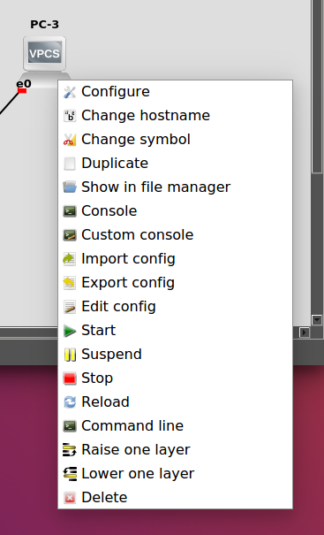

The important ones:

* Configure: configuring up the device before starting. It will mostly only be needed for switches, and then we'll emphasize it. (If the machine is not started, double-clicking on the machine brings this up.)
* Console: access to the given machine in the command line. (In the case of a started machine, double-clicking on the machine brings this up.)
* Start/Stop, as above
* Delete, if we messed it up

That's it, it's really that simple. You can also draw, take pictures of your work, save it (it's actually automatic), load it, import a device, but really that's all. We don't even ask for anything on the record about this, let's start the game instead!

# Task 2.: Creating the network

Let's create a simple network.

Ingredients: 2 PCs, 1 Ethernet switch, 1 router and a connection to the outside world.

Preparation:

– The PC could be a real PC operating system, e.g. there are very dumb Linuxes available that use very little memory. They can be easily used in GNS3, but we will use an even simpler tool, VPCS (Virtual PC Simulator). It's a simple little system in which you can configure basic network stuff, ping, traceroute, etc. is at your disposal. It takes up little memory and is easy to use. Let's have two of it!

– Ethernet switch. An eternal classic. Layer2 processing, nothing extra. Oh well, it will know VLAN tagging anyway. Connect the two PCs through it. When laying down an Ethernet (i.e. UTP) cable, we have to choose which port of the given device to plug it into.

– Router. This is no longer included with the GNS3, but we prepared one, among other devices, under the name MikroTik CHR 6.41.4. Four Ethernet ports are needed, but there are only two by default. Let's add two more! (Right button, Configure, Network, Adapters: 4). Now connect the ether2 interface to the switch! (This is quite important: the ether2!) In the case of the switch, it doesn't matter which port we use in which direction, on PCs there is only one.

– If you haven't done it yet, turn on Show/hide interface labels above now!

– In GNS3, the connection with the outside world is called the cloud, which in this case is the Ubuntu operating system. Let's take one of these. (Caution, don't use NAT, although it also has a cloud icon.) After it has been installed, delete the eth0 interface in the settings and add virbr0 (it can be found in this way: right click, Configure, Ethernet interfaces, then - trick! – Show special Ethernet interfaces). Black magic, of course, but the point is that it works that way. Connect the cloud to the router, its ether1 port! (It is important that the port shall be good!)

– A little trick for the connection: if the links are not too short, a small magnifying glass will appear on them later, while we analyze the traffic going there. They should be slightly longer than the router icon. Let's say double that.

Now we can start the devices: . If everything is fine, the small squares at the end of the links will turn green.

**T2.1** We ask for a screenshot from the network here![2] (A Show interface labels  legyen bekapcsolva!)

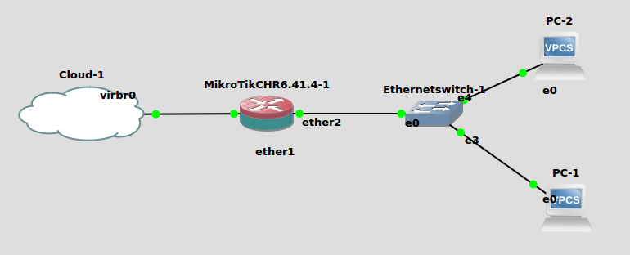

## VPCS

Let's get familiar with the virtual PC! After launch, enter: right-click and Console, or double-click. (Sometimes you have to hit enter for the prompt after the terminal appears.) The ? command lists the options. These are the most important:

* show ip : shows the IP address and other IP settings
* ip 1.2.3.4/24 1.2.3.5: 1.2.3.4 will be our static IP address with a 24-bit netmask (255.255.255.0) and 1.2.3.5 will be the IP address of the default gateway.
* ping, traceroute: the well-known tools
* dhcp, dhcp –r, dhcp –x: IP address request/renewal/deletion with DHCP protocol

Using the first two commands (show ip, ip) we can already configure the two PCs with static addresses so that they can ping each other through the switch. For the time being, the two IP addresses are arbitrary, as long as they belong to the same subnet! In both cases, the default gateway should be the other machine.

Note: Ubuntu's window manager handles windows of the same type differently than Windows. If, for example, we have two terminal windows, we can not switch between them with Alt-Tab, but with Alt-0 (or instead of 0 with the key above Alt on the keyboard).

**T2.2** Let's configure them, ping between the two machines. We would like a screenshot from both terminals! (One ping is enough, since if one sees the other and the ping comes back, it will also go the other way around. Not always, but in this simple case yes.)

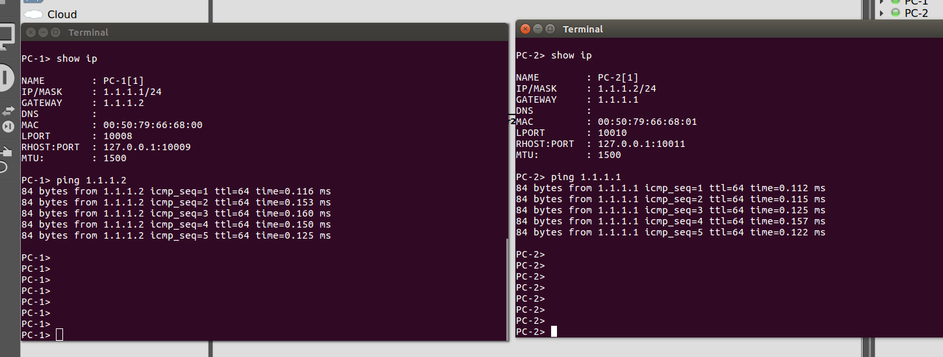

*Feel free to play with the network devices* now and throughout the measurement! Take your time, add new tools, reconfigure, try what happens if... In other words, experience the joy of discovery! That's how you can really learn!

## MikroTik

First we connect to the router with a command line console. (Right mouse button and Console, or double click.)  
Login name: admin  
No password (only press Enter).   
However, you have to wait after starting the machine, an operating system actually boots, and this takes some time.

It also has its own operating system (RouterOS), whose command line management is similar to that of other routers, but of course a little different. You can start typing a command and then complete it with the Tab key. The first step:

ip address print

None of the interfaces have an IP address yet. Let's request one with DHCP over the cloud from Ubuntu:

ip dhcp-client add interface=ether1

Let's see if it worked:

ip address print

If we didn't get an IP address right away, don't worry! Let's wait about 15 seconds and see if we got it yet!

**T2.3** Write the parameters of the received IP address here:

Interface: ether1  
IP address: 192.168.122.32  
The number of 1 bits at the beginning of the netmask: 24

Now that it has an IP address, our router sees the outside world through the Cloud network element. Let's try it, ping www.bme.hu from the router! (Stop: Ctrl-c) If everything goes well, the ping works.

**T2.4** Ping the good old www.bme.hu from the router! Take a screenshot of the result!

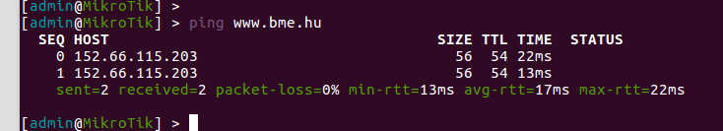

## Extra: NAT after NAT

*This part is interesting, but it can actually be skipped. There is no task attached to it.*

Let's think a bit about IP addresses! Using the example of a common case, we illustrate how the IP address of the ping packet changes if you run GNS3 from home and your laptop is connected to the home network with, say, a wired Ethernet. (There is no big difference with WiFi either.)

1. We start from the address described in the answer to task T2.3, this could be e.g. 192.168.122.188 (this can be a bit different for everyone.) Who gave this to our router, who was the DHCP server? GNS3 hides this from us, let's just say it's the GNS3 system. In addition, this is a NATed address. Open a terminal in Ubuntu and type: ip addr. We will see that it has the default gateway for this address: is the address of the virbr0 interface 192.168.122.1.
2. It also shows that the address of the local Ethernet card (in our example) is 10.0.2.15. (This shows that the address described in point 1 is NATed.) So where did this come from? Obviously from VirtualBox, since it also performs NAT. (At least that's how it's set up now.)
3. In our example, VirtualBox runs on Windows as the host operating system. Here we can also give the ipconfig /all command in a command prompt window. We see quite a few interfaces, but this one is assigned to the address of the Ethernet card: 192.168.1.205. (In the case of WiFi, the IP address of the WLAN card is of interest here.) This is given by the local (real) router installed by the internet service provider in the apartment. It's also NATed, y'all.
4. The router already has a "real" IP address, to which NAT translates the internal addresses. You can check this in the router's settings if you can access it, but websites like <https://whatismyipaddress.com/> also tell you, since it is sent with an http request.

You can see how many times the IP address changes in the ping packet by the time it reaches Alma Mater. Of course, it's the same on the other side, only reversed.

## MikroTik/WinBox

Our router finally has an address, it can see the outside world. This is also great because from here we can connect to it with an external program, with which we can edit its settings on a graphical screen. This is probably more convenient than the command line, at least at first. MikroTik released such a program called WinBox. Nomen est omen, the name obliges: the program only runs under Windows. And we have Ubuntu, but luckily WinBox works well with the Windows emulator called Wine. This is also prepared for you. Open a terminal window (left icon row, right button, New Terminal) and type the

./winbox

command. You have to wait a bit, and then the program will start.

Sometimes it finds router by itself, but in this environment it is not always true, so it is better to enter the IP address learned in T2.3. Type this in the top line, nothing else needs to be changed. Then Connect (not Connect to RoMON). If everything is true, the graphics program starts.

At this point, stop for a moment! What are we doing now? Well, we configure the router with an external program. If the router were a physical device, we would still do this: WinBox would run on our PC, it would connect to the device via Ethernet, and we could configure it that way. Most home WiFi routers run a web server and the router can be configured from a browser. Although our MikroTik router also has a web interface, using WinBox is a little more convenient.

Take enough time now to familiarize yourself with the configuration interface! The "LAN Measurement User Guide" document attached to the measurement describes WinBox in detail. It's worth checking out, especially the "2.1.1 Connection, Main menu" section. Tip: by default, WinBox comes up with very small letters. Although this is quite common, I think many people will heave a sigh of relief after issuing the Settings/’Zoom in’ command. (Then you have to make the window a little bigger.)

**T2.5** Insert a screenshot from WinBox showing the content of the following four windows at the same time:

* DHCP client data: (tip: IP/DHCP client)
  + The interface
  + The received IP address (if necessary, drag the column wider!)
  + The expiration time (DHCP addresses must be renewed from time to time)
* The interfaces (list of four Ethernet connectors)
* IP addresses - now there is only one (hint: IP/Addresses, and again: see the entire column!)
* The system time

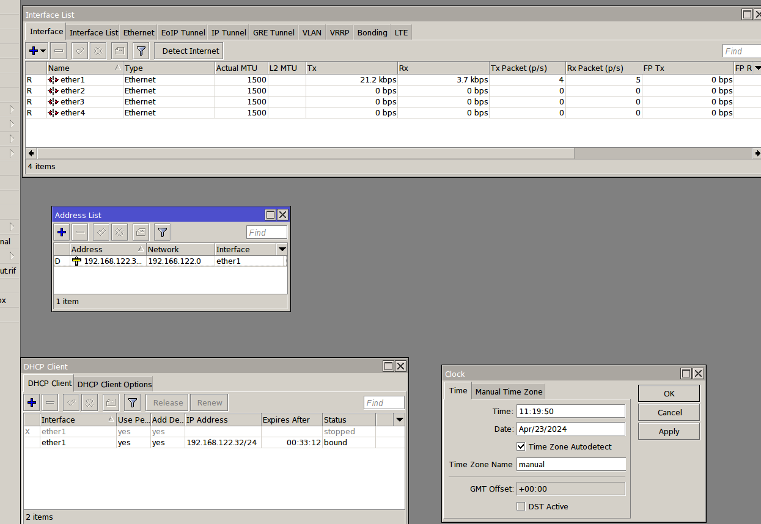

Let's clean things up a bit: close the windows in WinBox.

## Configuring the DHCP server

Now that we have a smart router, let's leave the IP address assignment to the PCs! It is not exactly 21st century to set the IP addresses manually, as we did in T2.2. Of course, we will use DHCP for this, i.e. we will start a DHCP server on the router.

This will require four things according to RouteOS:

1. the router will be the default gateway, so it must have an IP address on its interface that it listens to, and which you can announce as a default gateway with DHCP in addition to the issued IP addresses
2. an address range (pool) from which addresses can be allocated
3. a DHCP (sub)network, in which all the addresses of the address range (pool) are listed (more may be included, fewer are not), and the netmask and default gateway are set here
4. the DHCP server itself, which serves requests on a given interface

Let's set these up:

*STEP 1.* The IP address of the router should be 192.168.88.1. This can be added in the IP/Addresses menu with the blue plus sign. The netmask must also be entered here, it should be /24, we write this right after the address. If we choose OK, the machine will automatically guess the Network address from this. Before that, however, let's set up the interface correctly: you have to figure this out yourself based on the network (help: the virtual PCs will ask for an IP address!). OK can come now*.*

It is important that you never have to "save" what you set in the router, it takes effect immediately.

**T2.6** Create the new IP address and document it with a screenshot! (If necessary, make the columns wider so that the entire content is clearly visible!)

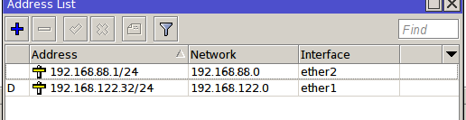

*STEP 2*. A new domain can be created at IP/Pool. (Before that, you can close unnecessary windows in WinBox.) The name should be, say, pool88. The range should be 192.168.88.2-192.168.88.254. (This is exactly how it should be entered in the Addresses field, so in one line, with a hyphen, no spaces are needed.)

**T2.7** Why do you think 192.168.88.1 was left out?

Because the IP pool range is used for dynamically assigning IP addresses to other devices on the network. The 192.168.88.1 is the default gateway (address of the router in the subnet) and it is not supposed to be given to other devices in the network. Imagine assigning this IP 192.168.88.1 (which is set in the DHCP server as the default gateway) to PC1 (i.e make PC1 as the default gateway) and not the MicroTik Router. You would not have access to the cloud at all.

*STEP 3.* The DHCP network can be found in the IP/DHCP Server under the Networks tab. Let's create a new one. Here, it is sufficient to fill in the first two lines, if the netmask is written in the form /xx after the address.

**T2.8**  Create the DHCP (sub)network and document it with a screenshot! Now you have to figure out the parameters yourself, but it won't be difficult. Only the first two lines need to be filled in.

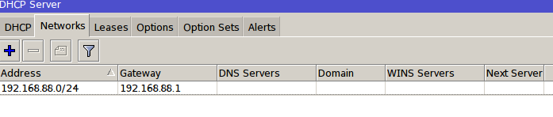

*STEP 4.* Setting up the DHCP Server. It is on the DHCP tab, you need to create a new one. The name should be server88. You have to set the interface correctly here as well (the PCs will ask for an IP address), beyond that you only have to set the Pool to the previously created one. The router will automatically find the DHCP (sub)network created in the previous point.

**F2.9** Configure the DHCP server and document it with a screenshot!

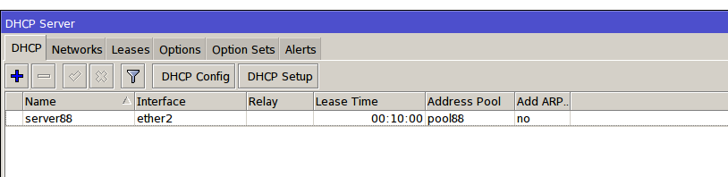

If everything is fine, the DHCP server (server88) line is black, and your server is ready. If the line is red, there is something wrong.

# Task 3.: Investigating DHCP and ARP

## Requesting an IP address

It's time to get back to GNS3 and get PCs to request an IP address from our fresh DHCP server. But before we do that, let's start Wireshark to analyze the traffic: right-click on the link between PC1 and the Ethernet switch (not on the labels, if they're in the way, move them away), and Start capture/OK. If the link is long enough, a magnifying glass will appear on it and Wireshark will start. Wireshark starts nicely configured, we don't have to deal with it now. (The "How to" document can help you use WireShark if you get stuck.)

In the console window of PC-1 (right click, Console if it has already been closed, and you may also need to press Enter), issue the DHCP request command:

dhcp

Note: If you had already requested an address before starting Wireshark, then with the dhcp -x command it can be returned (dhcp lease release), and then a new one can be requested (dhcp command).

Then - ideally - it says "DORA", maybe "DDORA", and then the IP address you received (although not always the latter). If we only have a couple of "D" letters, then something is wrong, we did not receive an IP address.

**T3.1** Let's look at the IP address you received! (show ip command)

IP address/netmask: 192.168.88.254/24  
Default gateway: 192.168.88.1  
Does this match the DHCP settings you just made?   
Yes this matches with the network address ( 192.168.88.0/24) and submask. The IP assigned is also in the range of the pool pool88 (2-254) that the DHCP is using.  
The default gateway is the same one as set in the DHCP configuration.

**T3.2** Let's take a screenshot of the DHCP process from Wireshark!

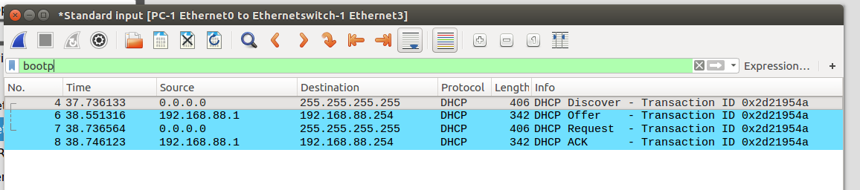

**F3.3** Based on these, what does the "DORA" seen above mean? (one-one word is enough for an answer)

D: Discover  
O: Offer  
R: Request  
A: ACK

Now we can stop capturing packets: right click on the link, Stop Capture. However, don't close Wireshark yet, you will need it soon (Task T3.5).!

**F3.4** Let's also ask an IP address with DHCP for PC-2. Which address did we get?

The received IP address: 192.168.88.253/24

Since this is a LAN measurement, in Wireshark[3], which is still open, let's take a closer look at the Ethernet header of the first (marked "D") DHCP packet of the DHCP address request!

**T3.5** Which fields does the Ethernet header consist of, how many bytes long are they and what do they contain?

Destination MAC address(Destination), 6 bytes, ff:ff:ff:ff:ff:ff  
Source MAC address(Source), 6 bytes, 00:50:79:66:68:00  
EtherType (Type), 2 bytes,0x0800  
CRC~not there

Notes:   
EtherType tells you what kind of payload the frame carries (08 00 is IPv4).  
 After the headers mentioned above the payload should come and then the CRC of the frame,but we can not see the CRC part because it is stripped before being passed to the system by the NIC. (Maybe here things are emulated so it may be different but the thing is you can't find the CRC part in our packet in wireshark).

Note: If we expand the Ethernet frame in Wireshark for closer inspection, we can see that part of the MAC address (or Ethernet address or "physical address"[4]) is replaced by Wireshark with the keyword "Private_". Why are you doing this? We wrote about this topic in the measurement guide, but we will briefly repeat the essence here as well.

The point is that Ethernet addresses consist of 6 bytes and are, in principle, unique in the world. This is achieved by allocating the first three bytes to the hardware manufacturers, within which they are responsible (with the second 3 bytes) for ensuring that no two hardware interfaces have the same name. The first three bytes (Organizationally Unique Identifier, OUI) therefore identify the manufacturer, and Wireshark uses this and writes the manufacturer instead of these bytes.

The author writes all this on a Dell laptop, and when tested on the host operating system there, Wireshark actually changes the beginning of the address to "Dell_". Of course, it also shows the original. Here, in the simulated environment, devices are assigned a special "Private" manufacturer ID address.

We can now close Wireshark without saving packets.

## Adding another subnet

Add another PC to the network, this will be PC-3. Connect it directly to the router, to its Ethernet interface 3! (Pay attention to this: interface 3!) This time, for the sake of simplicity, let's set the IP addresses statically. Your PC should be 192.168.77.2/24, your router should be 192.168.77.1/24.

Help: you have already seen and tried how to set a static IP address for the virtual PC and also how to assign a static address to a router interface.

**T3.6** Let's ping PC-1 from PC-3 to demonstrate how everything works. Take a picture of the window!

I don't know what is meant by window. I assumed the terminal was ment or the network.  
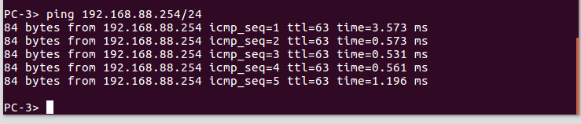  
  
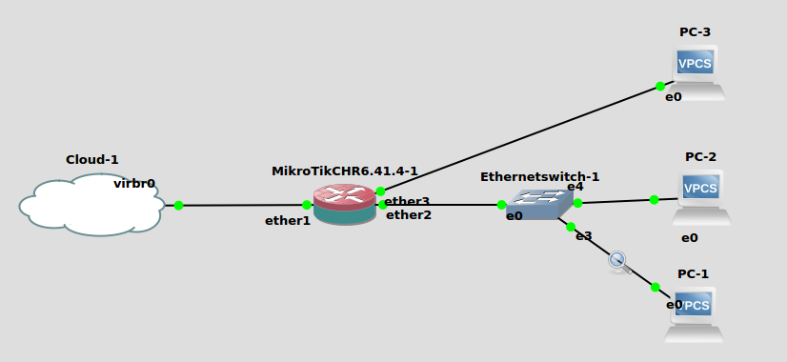  


## Investigating ARP

Let's get to know the ARP protocol more closely! The theory was (or will be) presented in a lecture and briefly (only half a page!), but hopefully comprehensively summarized in Chapter 1.2 of the LAN Measurement User Guide. This is definitely worth reading before you move on!

Let's see all this in practice! On the PC-2 console, issue the following command:

show arp

If it shows anything other than "arp table is empty", that's not very good, but it just means that we've used this machine recently. It will forget the entries after a maximum of two minutes, let's wait that.

Note: We can also use this time to think about the fact that our own PCs also have such an ARP table. We can try it! Under Windows (in a command prompt window) use arp -a under Linux only arp. Under Windows arp -d * deletes ARP table entries, you do not have to wait, if we are impatient. Under Linux deletion requires root (admin) rights.

Let's start packet capture between PC-2 and the switch! Ping PC-1, then stop the ping.

**T3.7** What's in the PC-2's ARP Table? (show arp, it is enough to copy it here textually). Interpret what you see!

I see this: 00:50:79:66:68:00 192.168.88.254 expires in 16 seconds  
This is what it means: This entry in the ARP table associates the MAC address "00:50:79:66:68:00" with the IP address "192.168.88.254". It indicates that the MAC address "00:50:79:66:68:00" is the hardware address corresponding to the IP address "192.168.88.254". Additionally, the entry mentions that this mapping will expire in 16 seconds.

**T3.8** View captured ARP packets in Wireshark!

For some reason the first time I did the measurement I had 4 ARP packets but now everytime I try I have 2 but will leave the previous answer below.  
  
***Second Time of measurement***: (Several time I got this)  
  
—---------------------------------------------So packets for PC-2 <-> PC-1-------------------------------------------------

Whose MAC address did the request come from? PC-2 (00:50:79:66:68:01)  
Whose MAC address did the request go to? Broadcast (ff:ff:ff:ff:ff:ff) (everyone in the 192.168.88.0/24 subnetwork).  
What is the essential part of the request, i.e. in which field is the question to which the sender is waiting for an answer? Target IP Address (192.168.88.254). PC-2 is asking for the MAC of the host with this IP.

Whose MAC address did the reply come from? Router (00:50:79:66:68:00)  
Whose MAC address did the reply go to?PC-2 (00:50:79:66:68:01)  
In which field is the answer to the question? Sender MAC address (00:50:79:66:68:00)  
  
  
  
***First Time of measurement:***  
There were 2 requests and 2 replies. First PC-2 asked (actually broadcasted the the request for the MAC address of IP 192.168.88.1 which corresponds to the router) the router for its MAC address. Then the router replied with its MAC address.. Then PC-2 proceeds to ask (broadcast) for the MAC address of the user with ip 192.168.88.254 (PC-1). The PC-1 then replied with its MAC address.   
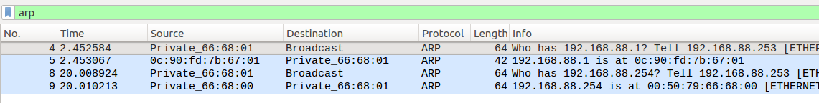

—--------------------------------------------So packets for PC-2 <-> Router-----------------------------------------------  
Whose MAC address did the request come from? PC-2 (00:50:79:66:68:01)  
Whose MAC address did the request go to? Broadcast (ff:ff:ff:ff:ff:ff) (everyone in the 192.168.88.0/24 subnetwork).  
What is the essential part of the request, i.e. in which field is the question to which the sender is waiting for an answer? Target IP Address (192.168.88.1). PC-2 is asking for the MAC of the host with this IP.

Whose MAC address did the reply come from? Router (0c:90:fd:7b:67:01)  
Whose MAC address did the reply go to?PC-2 (00:50:79:66:68:01)

In which field is the answer to the question? Sender MAC address (0c:90:fd:7b:67:01)  
  
—---------------------------------------------So packets for PC-2 <-> PC-1-------------------------------------------------

Whose MAC address did the request come from? PC-2 (00:50:79:66:68:01)  
Whose MAC address did the request go to? Broadcast (ff:ff:ff:ff:ff:ff) (everyone in the 192.168.88.0/24 subnetwork).  
What is the essential part of the request, i.e. in which field is the question to which the sender is waiting for an answer? Target IP Address (192.168.88.254). PC-2 is asking for the MAC of the host with this IP.

Whose MAC address did the reply come from? Router (00:50:79:66:68:00)  
Whose MAC address did the reply go to?PC-2 (00:50:79:66:68:01)  
In which field is the answer to the question? Sender MAC address (00:50:79:66:68:00)

Note: it looks like the given VPCS ARP implementation is faulty and the VPCS is sending somewhat faulty Ethernet frames. Wireshark also says this, but everything works anyway. Let's not bother with this anymore.[5]

Now let's ping from PC-2 to PC-3! You can use the captured packets or the result of the reissued show arp command to answer the question below!

**T3.9** Whose MAC address are we looking for now with ARP? Why, ie how does the PC-2 know to look for this MAC address? (This is not self-evident, but it is completely logical, you can figure it out.)

Whose MAC address are we looking for? The router is looking for the MAC address of PC-2 (192.168.88.253). (If i let arp entries expire then PC-2 asking for the MAC of the router).

**Note:** that if I let the entry corresponding to the router in the ARP table of PC-2 expire I would have seen 4 packets or ARP. PC-2 will also ask the router for its MAC address. You can see them here one after the other after I let the entries expire in the ARP table of PC-2.

Something Interesting is that the is always sending an ARP packet when it is being pinged. It seems like odd behavior. It has the entry saved and still asks for it.

Why?

When PC-2 attempts to ping a destination outside of its local subnet (PC-3 its outside), it forwards the packets to its default gateway (router) for further routing which implies that it also asked for its MAC address.. The default gateway is responsible for forwarding packets to destinations outside of the local subnet and back to PC-2 in this case.

If you are interested, you can view the router's ARP table (IP/ARP) in WinBox.

Let's stop the packet capture (right click on the link, Stop capture)! We can close Wireshark.

## Creating a NAT on the router to complete the joy

Our PCs can communicate with each other (you can check it with ping), but they cannot see the outside world yet: ping www.bme.hu will not work (not even with an IP address instead of a name). You can also try this from, say, PC 1. The reason for this is that the router does route, i.e. nicely forwards the packets between its interfaces, but it does not advertise this local address range to the outside world (it does it right, these are addresses that can only be used in the local network), so the ping cannot ’return’ to the addresses of the virtual PCs.

In fact, this poor router does not advertise anything to anyone, since we have not started any routing protocol on it. Don't worry, this measurement is not about, we can get by without a routing protocol.

The only solution is NAT, the hiding of internal addresses in outgoing packets, who knows how many times we used it today. The implementation of this is not so important from the point of view of the measurement, but it is somehow interesting, so we included it. We will help, or more precisely, we will describe step-by-step what needs to be done:

Open the IP/Firewall window in WinBox! Create a new rule with the + button on the NAT tab:

General tab: Chain: srcnat, Out. interface: ether1 (no need ! before it)

Action tab: Action: masquerade

Let's press OK.

**T3.10** Let's ping www.bme.hu again from PC 1, it should go now. Take a picture of the window!

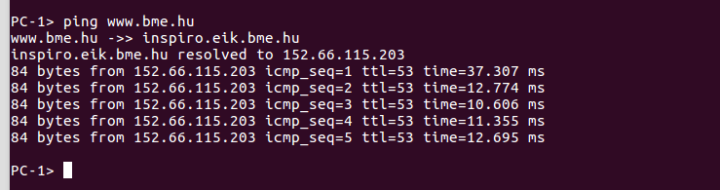

# Appendix: GNS3 Installation Dilemmas

As a point of interest, we describe approximately what the main steps of installing GNS3 would be:

• A graphic client must be installed on our own computer (Windows, Linux and Mac clients exist)

• A virtual machine must be installed on which the GNS3 server will run

o The server can also run natively on the host OS, but according to the authors of GNS3 there are problems with this, it is recommended only under Linux

o Under Windows, it mainly only works properly with VMware, although in principle it should also work with VirtualBox and other software. It is also advisable to install VMware if you haven't already.

o VMware requires an add-on called VIX, which recently is not really supported by the free VMware Player, but can still be used with a little skill

• Each device starts as a separate virtual machine within the server running on the virtual machine. Most of these images must be downloaded and installed separately first.

For those who like challenges, we have prepared a guide for this as well, if requested, we will provide it (although the text is still quite raw). It can be put up in a couple of hours and you can still measure it, but we were looking for a simpler solution.

Of course, the solution is the usual one: let's create a virtual machine (Virtual Machine, VM) in which we pre-install and configure everything so that we just have to use it. The only problem would have been that at that time the GNS3 client was running in this VM, next to it in another VM (within the VM, so this is level 2) the server, and in each of those VMs ( Level 3) the tools.

At this point, the help of the colleagues mentioned on the front page, who made the other half of these 3 levels, came in handy. Of course, the whole thing was put in a VM, because that's the point, but the GNS3 server was already installed natively and the devices also only have a "lightweight" virtualization, so-called They use Docker containers.

You don't have to see much of all of this, just start and go.

1. VirtualBox has a so-called "host key" key combination. This can be configured, by default the right Ctrl key on Windows, the left Command key on Mac. By pressing this, we are "released" from the guest operating system, and keystrokes and mouse clicks are directed to the host operating system from here on. Typical usage: host key, then Alt-Tab.
2. For example: in Ubuntu press the PrintScreen key, in the pop-up window Copy to Clipboard, and in Windows paste in some drawing program, then cut out (crop) the essence.
3. If we accidentally closed it, no problem! Let's restart packet capture, we need on the PC dhcp -x, then dhcp and we are ready.
4. Although this is not the physical layer, it is sometimes called that, in contrast to the network layer (IP) address. Speaking of which, MAC stands for Medium Access Control, which is a part of the Data Link Layer, the lower sublayer. The physical address is therefore too imprecise, the MAC is somewhat too precise, but no one calls it a "data connection address". C'est la vie..
5. The developers aren't too worried either: <https://github.com/GNS3/vpcs/issues/9>: "ghost commented on Nov 8 2017 Won't be fixed." Well, that's how we went.